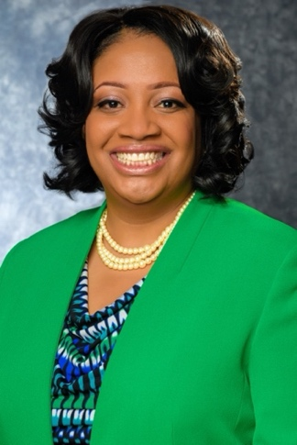

Most recently, Wendy McSweeney was the Commercial Community Bank (CCB) Diverse Segments Business Development Officer focused on driving social influence and advancing diversity, equity, and inclusion (DEI) within Truist’s client base. She oversaw the development and execution of Truist’s go-to-market strategy for the Diverse Segments Business Development team for people of color- and women- owned business clients and prospects ranging in size from $25MM-$500MM in annual top line revenue. Wendy leveraged her DEI expertise to proactively partner with local commercial banking teams to acquire new clients and deepen existing relationships. She delivered specific content and customized solutions, as well as provided market commentary and views of the competitive landscape to support clients with highly complex financing needs.

Prior to moving into this role in April of 2022, McSweeney served as Truist’s Chief DEI Officer for eight years where she fostered a more purpose-, mission- and values-driven working environment at Truist, through her thought leadership, counsel and focus on inspiring and building better lives and communities. She led the Diversity, Equity and Inclusion Office and team; oversaw eight company-wide business resource groups; served on the Operating Council; developed community partnerships; and represented the company's commitment to DEI. A veteran of the financial services industry, previously she worked for Wells Fargo Advisors (WFA) for 11 years, where she held a variety of leadership positions.

Passionate about serving in our communities, Wendy is a board member of Usher's New Look, as well as an advisory board member of the Atlanta Braves Henry Louis Aaron Fund. She previously served on the boards of Men for Hope, National Organization of Black Law Enforcement Executives (NOBLE), POSSE Foundation and Ron Clark Academy. McSweeney received recognition from ICABA as a 2022 Women of Impact Honoree, Technology Association of Georgia (TAG) as the 2019 D&I Individual Leadership Award recipient, in the Profiles in Diversity Journal 2018 Diversity Leader Award, and Black Enterprise as one of the "Top Executives for Diversity & Inclusion" in 2014, 2015, 2016, 2017, 2018 and 2019. In 2014, the National Diversity Council awarded Wendy one of the "Most Powerful and Influential Women" in Georgia.

McSweeney earned an undergraduate degree in accounting from Virginia Union University. She is a graduate of the St. Louis Business Fellow's Leadership Program, as well as a proud member of Delta Sigma Theta Sorority, Incorporated. Wendy lives in Atlanta, GA and is the self-proclaimed “World’s Greatest Aunt”.

