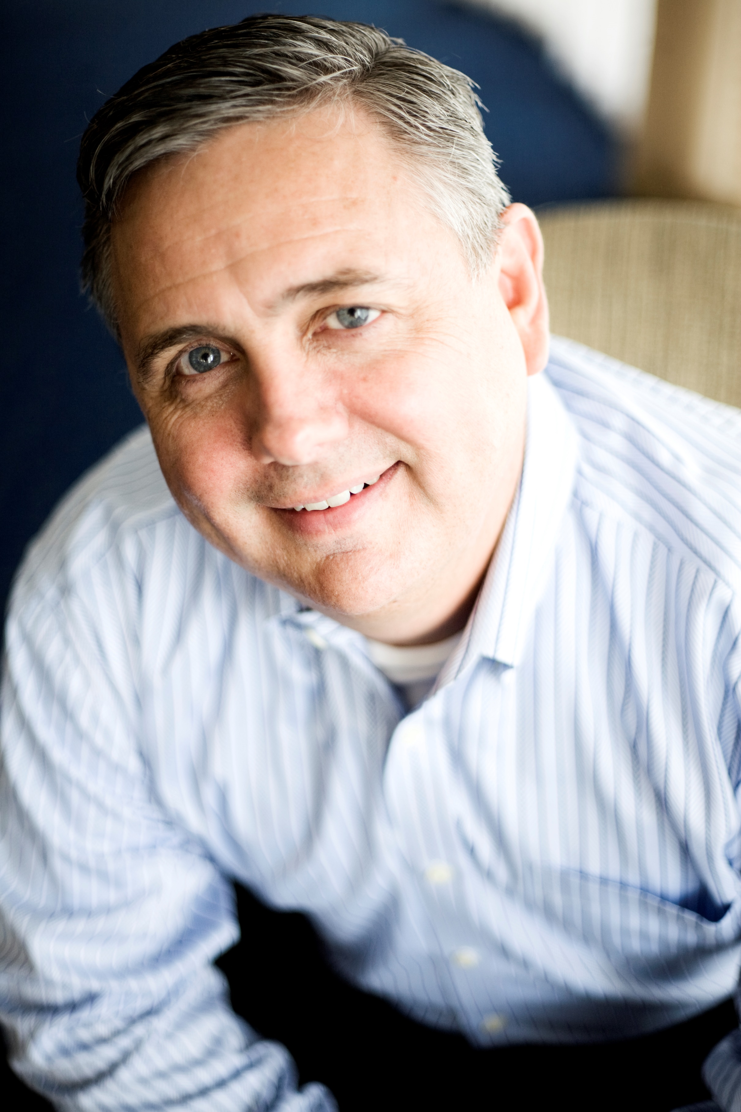 |  | Sean Geehan
Profile  Highly accomplished CEO and consultant with a proven record of transforming B2B organizations and driving exceptional revenue and margin growth.  Expertise in B2B strategy, product development, sales and marketing modeling, and building strong C-level relationships to deliver sustainable, predictable, and profitable growth.  Contact  PHONE:  937-271-3914  EMAIL:  sean@geehangroup.com  Hobbies  Coaching Water Polo |  | Key Experience  Geehan Group, Founder and CEO  2002–Present  - Advised C-level executives at world-class organizations across diverse sectors, including technology (CyrusOne, HCL, Salesforce, HP, SAP/Business Objects), healthcare (Patheon, AmerisourceBergen), and others.  - Led initiatives to address complex business challenges and deliver measurable results in B2B strategy, product development, sales and marketing optimization, and customer engagement.  - Developed and implemented B2B product development methodology that establishes differentiators and higher margin yields.  - Designed market dominating B2B marketing, sales, product development, GTM models and structures.  SKILLS and Uniqueness  B2B Expertise: Delivering B2B companies’ strategies and actions that grow revenue and margins larger and faster than the competition.  National Best Seller and Execution: The B2B Executive Playbook. Includes dozens of tangible examples of my successful work with mid and large organizations.  Member: E & Y National Entrepreneur Hall of Fame.  BS and MBA from University of Dayton.  Available for interim, fractional, and consulting assignments.

Client engagements, Quotes and experiences

Geehan Group, Client’s Experiences

- “We could have never imagined the results Geehan helped deliver from Day One, which have exponentially increased our relationships and revenue since.”
– Shami Khorana, Former Global President, HCL
Industry: Technology Services and Systems Integration
Length of engagement: 7 years

- “Sean and his team led our senior level planning for years along with many of our divisional market engagement programs. They were exceptional at strategy and aligning our senior team. Sean’s guidance and program was a game changer for us.”
- Dave Neu, President, AmerisourceBergen (Cencora)
Industry: Pharmaceutical Distribution
Length of engagement: 6 years

- “Geehan was the driving force behind our reorganized Customer Advisory Board. Their expertise ranges from writing Charters to developing the entire customer input process.”
– Buzz Waterhouse, Former CEO, Reynolds+Reynolds
Industry: Software and Systems Integration
Length of engagement: 3 years

- “Sean and the Geehan team were exceptional at strategy and aligning our senior team. In addition, they were at the center of building and developing high-level relationships with our biggest customers. Prior to their involvement, it was inconsistent at best and at lower levels. Sean’s guidance and program was a game changer for us.”
- Jim Mullen, Former CEO, Patheon Pharmaceuticals
Industry: Pharmaceutical
Length of engagement: 3 years

- “Geehan worked diligently with us to develop the strategy and plan as well as participated in the actual execution of our Advisory Boards... All of our clients (and us within CyrusOne) were very impressed with Sean, his company and how they conducted business with us.”
– Gary Wojtaszek, Former CEO, CyrusOne
Industry: Technology and Services
Length of engagement: 2 years

